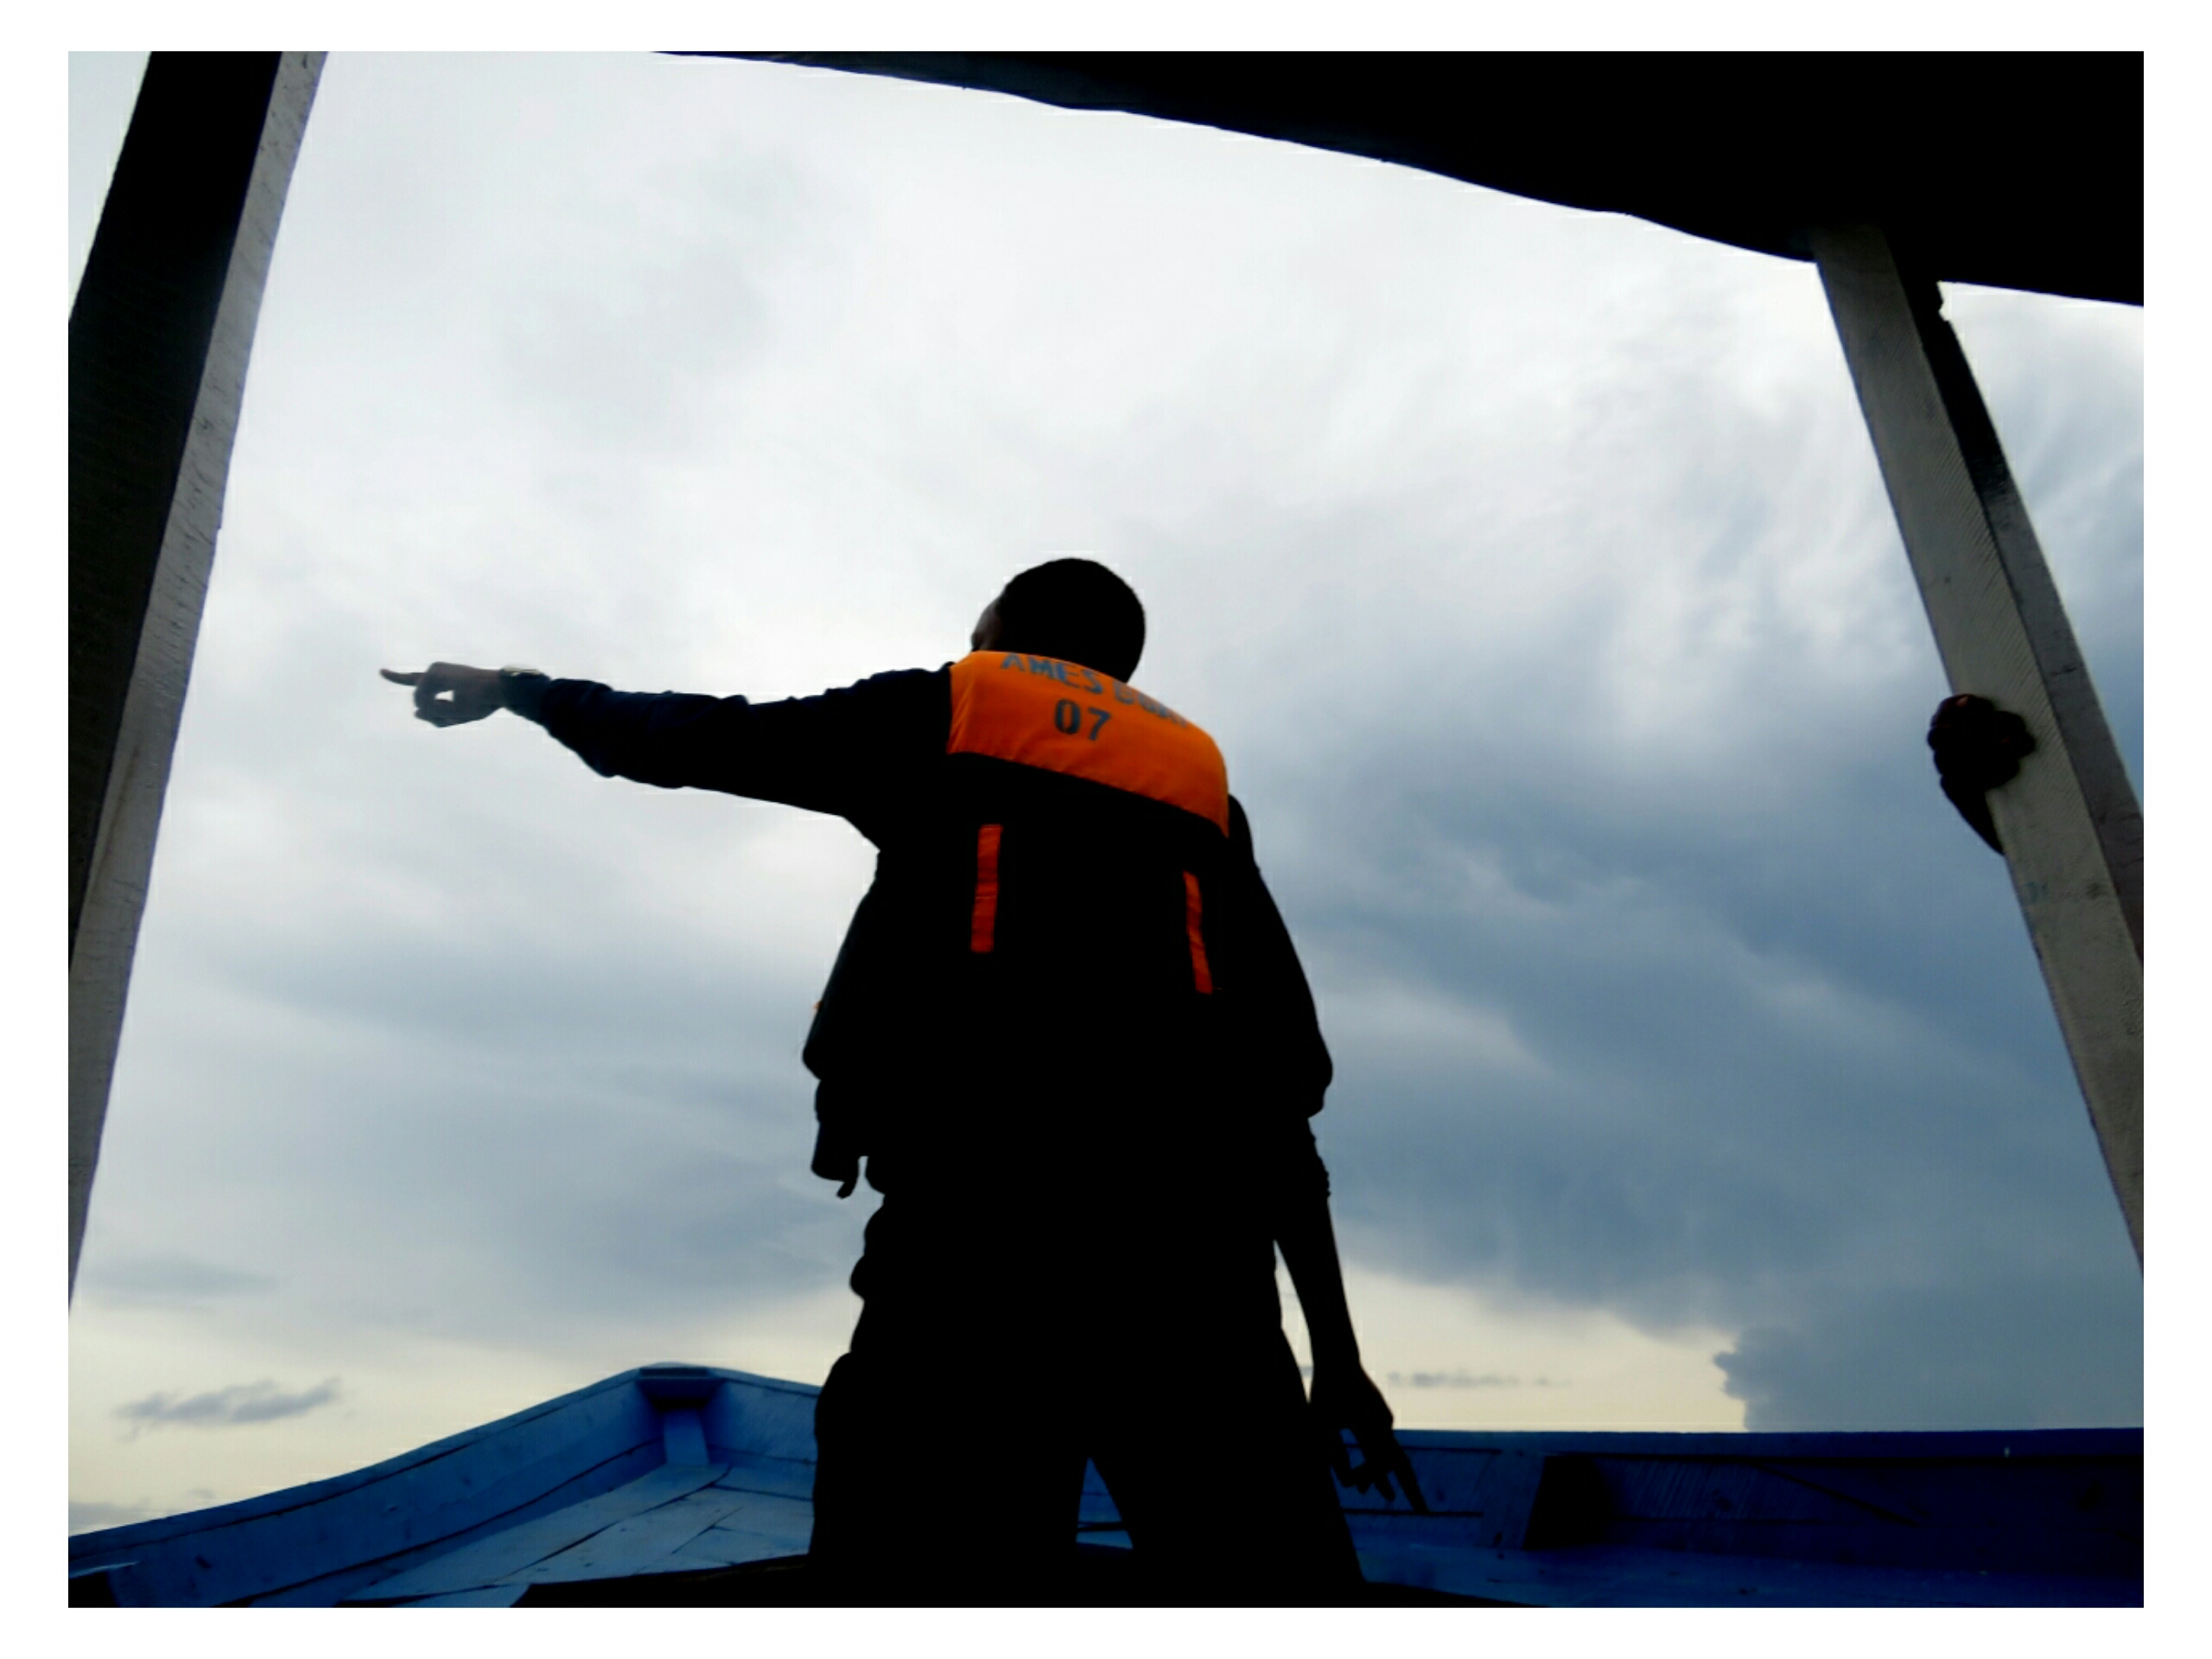
Story By: Joel Ndege, Age: 19

Men spend their whole lives looking for God,
Trying to see the face of God,
Trying to hold His Hand,
Trying to hear His voice,
They build grand monuments to honor His name,
They look up to the sky and pray for His grace,
They build alters to sway His favor,
They make sacrifices to gain His love,
Hoping that one day they'll catch a glimpse of Him,
Hoping that at the end of life,
They'll get to sit by His side,
But maybe, just maybe,
God isn't the man in the sky,
And He isn't seated on a throne in the heavens,
Maybe, just maybe,
God is that voice in your head,
That voice that tells you everything will be alright,
That voice that whispers strength into your ear,
Maybe, just maybe,
God is that invisible hand,
That picks you up when you're down,
That holds you up when the world is pushing you down,
Maybe, just maybe,
God doesn't reside in the skies,
God resides inside us.

